BiílaInstituteofTechnologyhScience,Pilani WoíkI⭲tcoíatcdLcaí⭲i⭲oPíooíammcsDivisio⭲ Scco⭲d Scmcstcí 2022-2023
Mid-Scmcstcí"cst(EC-2Rcoulaí)
Course No. : AIMLCZG512 Course Title:Deep Reinforcement Learning Nature of Exam : ClosedBook Weightage : 30% No. of Pages = 2 ; No.OfQuestions=5; Duration:2Hours; DateofExam:27-01-2024(FN)

NotetoStudents:
- Answerallthequestions.
- Writeyournameandsignattheendofallthepages.
- Assumptionsmadeifany,shouldbestatedclearlyatthebeginningofyouranswer.

Q1) [Write the answer in an A4 Sheet, Scan & Upload] Consider tic-tac-toe to answer this question.Assume that states are numbered from S₁ to S_{n}.
  - List the four elements of reinforcement learning and write one well-articulated formal statement explaining the role of each element. [2 M]
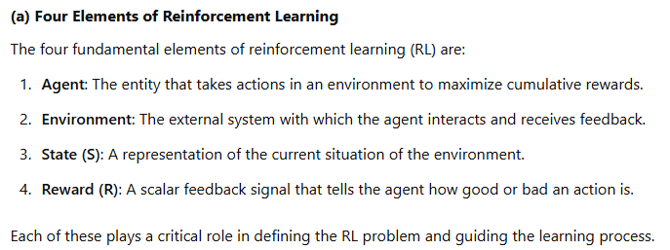
  - Write the temporal difference rule for learning each state's value. [0.5 M].Explain various elements and the workings of this rule. [1.5 M]
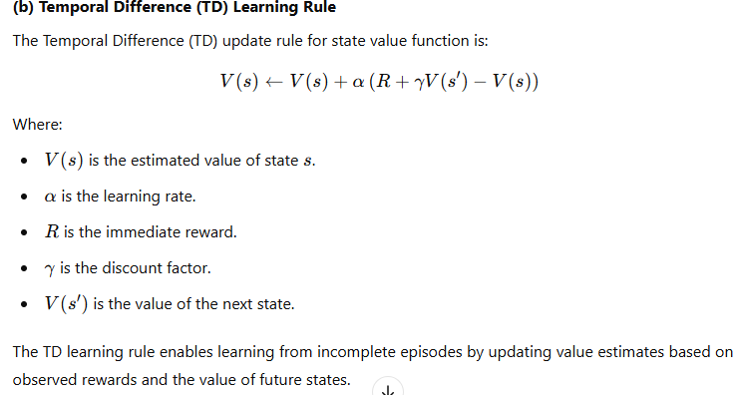
  - Let the value of the current state be 4.5, and all its possible successor/predecessor states have a value of 2.7. Use 0.9 to be the parameter value for anyparameter you need to use to solve this problem. Giventhis,Revise the estimate of the value of the current state using your answer to (b).Explain your answer [2 M]
[2.0+2.0+2.0=6 Marks]
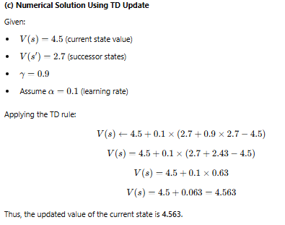

Q2)[WritetheanswerinA4Sheet,Scan&Upload]
- Write any one use-case (application) which can be modeled asamulti-armedbanditforits solution. Your answer should have all the elements that identify the use case and can be modeled as a multi-armed bandit problem. [2 M]
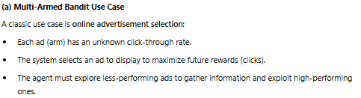
- Writedownabanditalgorithmthatisepsilon-greedy.[Note:onlyaformalalgorithmpseudo-code will be accepted as an answer.] [2 M]. Comment on the efficiency of this algorithm. [0.5 M].
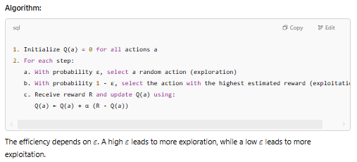
- Howdoesthisalgorithmbalanceexplorationvsexploitationtrade-off?Explain.[1.5M].
[2.0+2.5+1.5=6 Marks]
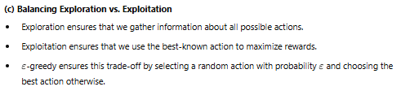

Q3)[WritetheanswerinA4Sheet,Scan&Upload]
- Devise two example tasks of your own that fitintotheMDPframework,identifyingforeach its states, actions, and rewards. Make the examples as different from each other as possible. [2 M]
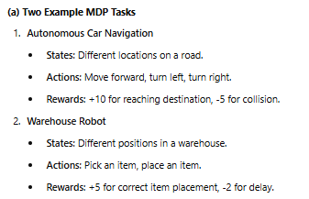
- In the following two cases you will find the reward sequences (Starting from R1) is given. You should find the Return (G₀ and G₁) in each case. Assume the 𝛄 = 0.8 in both cases.
  - An episodic task with T=5. The rewards received are R₁ = 1, R₂ =2,R₃=6,R₄=3, and R₅ = 2 [1.5 M]
  - AcontinuingtaskwithR₁=2,followedbyaninfinitesequenceof0’s.[1.5M]
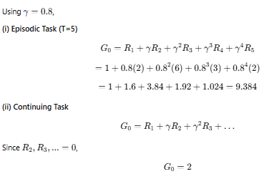
- Writedownthecompleteexpressionforeitherv_{𝝅}(s)orq_{𝝅}(s,a).[1.0M]
[2.0+3.0+1.0=6 Marks]

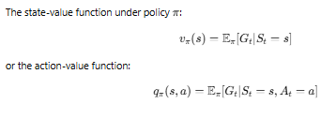

Q4)[Typeinthespaceprovided]
- What do you perform in Policy Evaluation andPolicyImprovement?Howaretheyusefulin estimatingoptimalpolicy? [ Answer must be phrased using formal, unambiguousstatement ] [2 M]
- Provide a high-level algorithm for policy iteration. Use the computation of either action or state values. Make necessary assumptions.[2 M]
- Explain the characteristics of reinforcement learning problems for which a dynamic programming solution is appropriate. Provide any two examples of problems. [2 M]

[2.0+2.0+2.0=6 Marks]
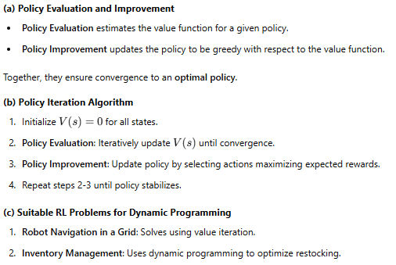

Q5)[WritetheanswerinA4Sheet,Scan&Upload]

- Assume you have data in the form of just the following 5 completeepisodes.Non-terminal States are labeled A and B, the numbers in the episodes denote Rewards, and all states end in a terminal state T.
  - A2A6B1B0T
  - A3B2A4B2B0T
  - A0B2A4B4B2B0T
  - B8B0T

EstimatethevalueofstatesofA&B.Showthesteps.[2M]
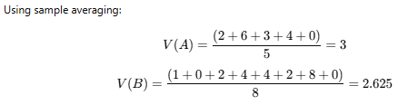
- What techniques monte-carlo algorithms use to ensure the exploration vs. exploitation trade-off is balanced.Write one line for each of the techniques stating their use. [2 M]
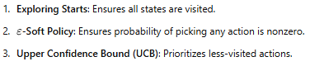
- Howare𝜺-softand𝜺-greedypoliciesarerelated?Asmallexample(astatewith4actions, with one of the actions being greedy) illustrates the working of 𝜺-greedy action selection. Assume suitable values for each action to help your explanation. [2 M]
